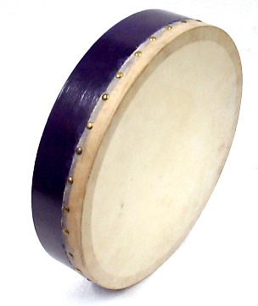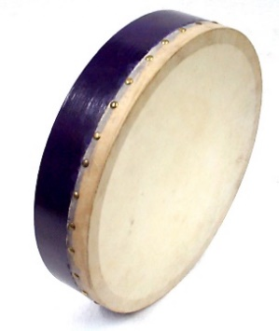

Muslim Women Association of Edinburgh event on Revitalise your Faith this Ramadhan
13 May 2017 by Sister Tayyiba.

A beautiful evening organised by MWAE on ‘Revitalise your faith in Ramadhan’ with a talk by sister Tayyiba held in Iqra Masjid in Edinburgh Scotland.
Muslim Women Edinburgh Association (MWAE) of Edinburgh is well known for Empowering Women and their families through Social and Education Activities since 2005.This group is run by volunteers working with women and their families in Edinburgh to build a stronger community through social and educational activities. MWAE also have youth clubs for younger children of different age groups.
This was the second event I’ve attended organised by MWAE, being new in Edinburgh I decided to give it a go, not only will I be learning about Ramadan but also get an opportunity to meet some local women.
The event was attended by over 50 ladies and children, MWAE had also arranged for a crèche, so the women could have a better focused session. The crèche was well planned and children had a lovely time with lots of interactive games for the children in a separate large room.
The women’s session was led by sister Tayyiba which started with the recitation of the holy Quran surah baqarah. The warmth in the voice had already touched my inner soul and I felt the connection. After the recitation sis Tayyiba started by explaining the beauty of the holy Islamic month of Ramadhan and how to revitalise your soul and faith.
The talk was clear, easy to follow with lots of reference from hadiths and quotations from the Holy Quran. What made it interesting was sis Tayyiba had a warm smile and an open approach to her explanation. Every explanation had a story or hadith to follow, there was no doubt what she talked on was well researched.
After the talk we had a break, MWAE had organised a coffee break with lots of delicious food and drinks. It was lovely to chat to women I had not met, I could feel the sense of friendship and a chance to share and discuss the lovely session.
After the break we had one more session which was the icing on the cake, the session was on the Nasheed and playing of the Duff. The Nasheed was read in Arabic and then explained in English. The Nasheed is a religious song.
I had never heard the sound of a Duff, we heard the most beautiful voices from sisters who had volunteered to play the duff and sing the Nasheed, the lyrics were passed around for other sisters to join in and everyone joined in the singing. We sang quietly as we were in the Mosque, we had children and women joining in. Though not an Arabic speaker myself I quickly googled the translation and joined the singing for the chorus part. This was the most beautiful and uplifting session I had ever experienced.
Thank you for the beautiful evening MWAE. Looking forward to the next event.

Nazima Khan

